**Function Description**

Given image describes how MORSE CODE is written, each single space indicates start of a new character, each double space indicates a single space between two words. You will be given dash(-) and dots(.), translate them to character according to rules of MORSE CODES.

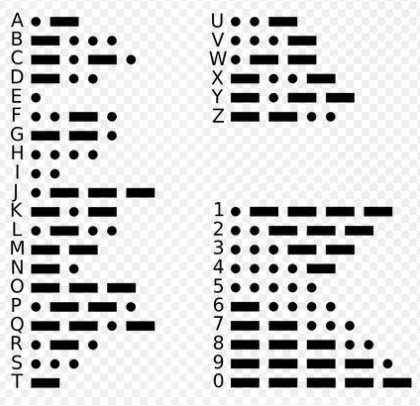

**Input Format**

The input will provide the code.

**Output Format**

Output should have the translation of the code.

**Sample Input**

- . ... - -- .- -. -.. ..

**Sample Output**

TESTMANDI